LONDON’S GLOBAL UNIVERSITY

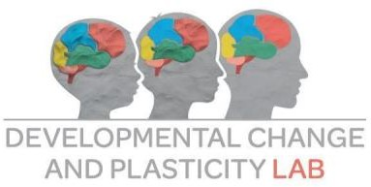

Dear Parent/Carer,

Your child’s school has kindly agreed to help us with an exciting new research project that is being carried out at University College London. We are writing to tell you about it and to invite you and your child to take part. The aim of the study, which is being funded by the Economic and Social Research Council (ESRC), is to better understand how prosocial behaviours such as helping, sharing and comforting emerge in children and the brain development that accompanies this.

Who are we?

The Developmental Change and Plasticity Lab is part of the Clinical, Educational and Health Psychology at University College London.

What will it involve for my child and I?

We are inviting you and your child to visit our research lab at UCL to take part in two sessions, one year apart, to complete some simple tasks testing the child’s prosocial behaviour. Your child will go through some behavioural tests with one of our researchers and you will also be given a questionnaire to complete. We also wish to study how brain development underlies these behaviours; therefore, part of the study involves your child completing a task while we scan their brain. We treat the safety and comfort of your child with the utmost importance; therefore, they will have the option to quit the study at any time, and all our researchers have received the highest standard of training to use the equipment.

What do I do now?

Please read the information that is provided with this letter. If you have any further questions, please contact the research team on dcp-lab@ucl.ac.uk or call us on 07739791633. If you are happy with the information provided and would like your child to participate in the stud, please sign the consent form that is attached and send it to us via e-mail.

With warm wishes,

Dr Nikolaus Steinbeis University College London
Professor of Developmental Neuroscience Division of Psychology and Language Sciences
26 Bedford Way, London, WC1H OAP Email: dcp-lab@ucl.ac.uk
Website: www.dcp-lab.org

Information Sheet for Parents & Carers
This study has been approved by the UCL Research Ethics Committee [Project ID Number]: 12271/004

Title of Study: A behavioural and neurocomputational study of prosocial development.

Department: Clinical, Educational and Health Psychology

Name and Contact Details of the Researcher(s): Rolando Bonandrini, Francis Beveridge; email: dcp-lab@ucl.ac.uk

Name and Contact Details of the Principal Researcher: Nikolaus Steinbeis, 26 Bedford Way, London WC1H OAP, Tel: 0207-679-5396; email: n.steinbeis@ucl.ac.uk

What is the purpose of the study?
This project forms part of a broader multicentric study involving UCL, Concordia University (Montreal, Canada) and Ludwig Maximilian University of Munich (Munich, Germany), with our main focus being to better understand how behaviours such as comforting, sharing and helping develop with age. We wish to invite your child to be part of a study which will involve coming to our lab at UCL for two sessions, one year apart. One of our goals is to also understand the underlying neural mechanisms of these changes in behaviour. This study and your participation will help us understand the extent to which these behaviours can be nurtured at an early age which will allow children to reach their full potential.

Do I have to take part?
No. You should only participate if you wish to; while we would encourage you to participate, choosing not to will not disadvantage you or your child in any way. Before you decide, it is important you read the following information carefully and discuss it with others if you wish. We would ask you to go through the age-appropriate study information provided for your child, so that they understand what the study entails. We will also go through this information again here at the lab should you and your child wish to participate. Please feel free to contact us if there is anything that is not clear or if you would like more information. Even if you decide to take part, you can withdraw your child at any time, without giving a reason. To terminate your participation, we have designated the divisional safety officer and laboratory superintendent George Joseph (g.joseph@ucl.ac.uk; Tel: 020-7679-5328), who is independent of the research team and thus not beholden to the goals of the study.

What does the study involve for me?

We are especially interested in how the brain develops over time and which areas underlie prosocial behaviour. Children will come into the lab for two sessions, one year apart, where

they will complete various behavioural tasks, one which will involve completing a task in an MRI scanner. You will accompany your child to our lab at UCL and will be given a questionnaire to complete. You will be waiting in the adjacent waiting room while one of our researchers goes through the behavioural tasks with your child in one of our lab rooms. You will receive similar levels of reimbursement for your time and travel for each of the two visits, while your child will be able to choose from a range of gifts as a reward for their participation. For this study we are recruiting 70 children aged between 5 and 6 years old. If you agree to participate, for each visit we will organize a time for you to visit us with your child - your visit should take around 3.5 hours in total and last no longer than 4 hours. For each visit, in the first part of the session we ask you to complete some questionnaires, for example, about your child’s behaviour, experience and personality, as well as their mental health. This kind of information is important as it can help us to better understand how well some children respond to our tasks. Any information you give during this session should be entirely voluntary and will remain strictly confidential unless required by law (e.g. if your child is at current risk of harm).

What does the study involve for my child?
The study involves you and your child coming to our lab at UCL on two occasions to participate in a series of behavioural tasks and for your child to have a scan using a brain scanner. The behavioural tasks are commonly used when studying child development and are designed in such a way that it will be engaging for children, meaning they hopefully will find it to be a fun day out. They will also have the opportunity to take plenty of breaks if they need to. Please note, your child is able to withdraw participation at any point during the study. Your child’s safety is our priority, we are a research team with lots of experience working with young children and have received training to spot non-verbal cues if they no longer wish to participate. One of our tasks involves listening to sounds that might be considered unpleasant. However, we will adjust the volume of sound presentation so that your child will not perceive these stimuli as discomforting. Scanning involves your child doing a few short tasks such as responding to colourful shapes. Please see the attached FAQ sheet for further details. The behavioural testing will take place on the 4th floor of the Psychology Department at 26 BedfordWay, London, WC1H 0AP. The MRI testing will take place in the same building, namely at the Birkbeck/UCL Centre for NeuroImaging at Bedford Way.

How will brain scanning be carried out?

Our imaging facility is designed specifically for research with very young children. The time spent inside the scanner is around 45 minutes: 25 minutes in which scanning occurs, and the remainder of the time used for checking on your child between the scans. We will try to make your child as comfortable as possible, with cushions and pillows for physical comfort as well as headphones for the noise that is made by the MR scanner. We also have a selection of MR- compatible stuffed animals, which your child is welcome to take into the scanner with him/her. There is an intercom with which we can communicate with your child. Your child can choose to stop the scan for any reason by pressing an alarm bell that they have with them. During the scan, we will ask you to wait in the adjacent reception room. Unfortunately, we cannot allow parents/carers to enter the fMRI scanner room or operator room, as this is not in line with our safety protocol of having only trained personnel being on-site. During the scan your child’s wellbeing is our top priority, and if at any point we feel like your child would rather not continue, we will stop the scan.

Will my child be video-recorded and how will the recorded media be used?

Some of the tasks will involve us recording your child’s facial expressions. The video recordings made during this research will be used only for research purposes. Only your child’s face will be filmed and only the research team based at UCL will have access to these recordings. Please note that your child’s face will be recognizable in the video. No other use

will be made of them without your written permission, and no one outside the project will be allowed access to the original recordings. We will be asking your consent below if we may use recordings for illustration in conference presentations and lectures, but if you do not wish for your child’s recordings to be used in this way, you and your child are still able to participate. You will be able to express or withdraw your consent to the use of your child’s video recordings for specific uses via the video consent form.

Will arranging a visit be difficult?
We hope not. If you wish to participate, we will call you and do our best to make your trip to UCL (UCL is near both Euston train and underground stations and Russell Square underground station) as straightforward and convenient as possible. For example, we will reimburse your travel costs, and talk you through directions. If you feel uncomfortable travelling within London, we are happy to send staff to meet you at the station. We want to make taking part an enjoyable experience – and will give your child (if they would like it) a CD with pictures of their brain to take away (and show off at school!) and prizes for participating, such as games and a t-shirt. You will be reimbursed for your travel expenses. Generally, each visit will last about 3.5 hours and last no longer than 4 hours.

What happens during the brain scan exactly?
We use magnetic resonance imaging (MRI) brain scans to measure brain activity. Children are given a few tasks that assess their decision-making. Additionally, they sometimes watch a cartoon or just lie still with their eyes closed for a few minutes. The tasks are designed for kids and involve (for example) making decisions about whether to press a button or not in response to visual stimuli. These tasks last only a few minutes. For the rest of the scanning time, we will be making a series of structural scans, among this also, the picture of the brain your child can take home. During this time, they can watch a cartoon and relax. Your child can choose to stop the scan for any reason by pressing an alarm bell that they have with them. During the scan, we will ask you to wait in the accompanying reception room. Unfortunately, we cannot allow parents/carers to enter the fMRI scanner room or operator room, as this is not in line with our safety protocol of having only trained personnel being on-site. During the scan your child’s wellbeing is our top priority, and if we feel like your child would rather not continue, we will stop the scan.

Is there a reason my child may not be able to take part?

Yes, we are looking at development in typically developing children. Unfortunately, this means if your child has a learning disability, this may not be the right study for them to participate in. However, if you are unsure if this applies to your child or you have any questions, we strongly would encourage you to get in touch.

Is there a reason my child may not be able to take part in MRI scanning?

Yes. Because the scanner uses a magnetic field, children who have any metallic implants or braces cannot participate. If your child is on prescription medication, or is afraid of small, enclosed spaces or loud noises, MRI is unlikely to be suitable. Please discuss any concerns you might have before participating.

Are there any side effects involved with MRI scanning?
MRI has been in use in medicine for about 20 years and has shown to be safe. It does not involve any radiation. People who have metal in their bodies (e.g. a pace maker) should not be scanned. We enclose a safety questionnaire with this information sheet so that we can be sure that it is completely safe for your child to be scanned. Please review this questionnaire and tell us if your

child has any of the conditions, which are listed. We will be happy to discuss this with you. The people who operate the scanner will also check that your child is safe to be scanned when you come to see us.

What are the possible disadvantages & risks of taking part?
There are none. All behavioural tasks have been widely used on child populations before and our study has received prior approval from the UCL Research Ethics Committee. However, you are still welcome to withdraw you and your child from the study at any point, without giving a reason. However, because we will be taking pictures of your child’s brain there is a remote possibility we will have unexpected findings. If this happens, our neuroradiologist (who specializes in looking at pictures of the brain) will write to your GP in the first instance. The GP will then contact you if further assessments are required.

What are the possible benefits of taking part in this research?
There are no immediate benefits. We do hope that taking part will stimulate your child’s interest about how the brain works. We are very experienced conducting studies with children involving brain scans and have found children often find coming to our lab to be a very exciting day out. Also, in the longer term you will help research that has potential to help other children in the future.

What if something goes wrong?

Should you wish to raise a complaint once you and your child have begun participating in the study, we would ask you to contact the Principal Researcher of the project, Dr. Nikolaus Steinbeis (n.steinbeis@ucl.ac.uk; Tel: 020-7679-5396). Should you, after having expressed your concerns, still feel that your complaints have not been dealt with adequately, we would ask you to contact the Divisional Safety Officer and Laboratory Superintendent George Joseph (g.joseph@ucl.ac.uk; Tel: 020-7679-5328) or the Chair of the UCL Research Ethics Committee (ethics@ucl.ac.uk).

Will the information be kept confidential?
Yes. All information that we collected is kept private and secure in a password-protected UCL safe database. We remove your name and address so that you or your children cannot be recognized from it. However, you are able to withdraw your data from the study up to 1 week after each testing point. All data will be collected and stored in accordance with the Data Protection Regulation 2018. We are by law required to notify relevant agencies if your child is at risk in any way. When we report the study findings, we do not identify individuals – instead our results report how participants do on average and do not refer to any personal information.

Use of Deception

Research designs often require that the full intent of the study not be explained prior to participation. Although we have described the general nature of the social tasks that your child will be asked to perform, the specific strategy adopted to achieve realistic interactions with a partner in the strictly-controlled lab setting will not be disclosed to you and your child until the end of the second session, at which point you or your child may choose to withdraw data from the study. Additionally, while we have asked your permission to record your child during the experiment, in order to collect the most accurate reactions from participants, we kindly ask parents not to inform their child they will be recorded. Children will be made aware of this after they have completed the experiment. The full intent of the study will not be explained to your child until after they complete the study, at which point you or your child may choose to withdraw data from the study.

What will happen to the results of the research project?

The results are likely to be published in peer-reviewed journals as well as PhD dissertations. Given the nature of the study and the number of participants, this will take around 4-5 years. We will provide regular updates on the progress of the study including a summary of the results to be sent to all parents and children that were involved in the study. No participant will be identified in any report or publication resulting from this study. This data will be stored in a data repository hosted by UCL, named Data Safe Haven, which will only be accessible by the research teams involved in this project. We follow open data practices, which will make anonymized acquired data available to other researchers, once the team has completed dissemination of the results.

Local Data Protection Privacy Notice

University College London (UCL) will be the data controller for this project. The UCL Data Protection Office provides oversight of UCL activities involving the processing of personal data and can be contacted at data-protection@ucl.ac.uk. UCL’s Data Protection Officer is Alexandra Potts and she can also be contacted at data-protection@ucl.ac.uk.

This ‘local’ privacy notice sets out the information that applies to this particular study. Further information on how UCL uses participant information can be found in our ‘general’ privacy notice:

https://www.ucl.ac.uk/legal-services/privacy/ucl-general-research-participant-privacy-notice.

The categories of personal data used will be as follows:

- Your child’s name and your contact details;

- ‘Special category’ data about your child (this may include details about your child’s race or ethnicity, information about your child’s health etc.);

- Video recordings of your child while performing experimental tasks measuring prosocial behaviour and related constructs; and

- Structural and functional MRI data of your child

The information that is required to be provided to participants under data protection legislation (GDPR and DPA 2018) is provided across both the ‘local’ and ‘general’ privacy notices.

Your child’s personal data will be processed for the purposes outlined in this notice. The lawful basis that will be used to process your personal data are: ‘Public task’ for personal data and’ Research purposes’ for special category data. You can provide your ethical informed consent by completing the consent form that has been provided to you below.

Your personal data will be processed so long as it is required for the research project. The data will be stored for up to ten years, in accordance with UCL’s data storage policy. We will pseudonymise the personal data you provide, and we will endeavour to minimise the processing of personal data wherever possible. If you are concerned about how your personal data is being processed, please contact UCL in the first instance at data-protection@ucl.ac.uk.

If you remain unsatisfied, you may wish to contact the Information Commissioner’s Office (ICO). Contact details, and details of data subject rights, are available on the ICO website at: https://ico.org.uk/for-organisations/data-protection-reform/overview-of-the-gdpr/individuals- rights/

What should I do now?
Please contact us if there is anything that is not clear or you would like more information. You can call Dr. Nikolaus Steinbeis on 0207 679 5396, or email: dcp-lab@ucl.ac.uk we would be very happy to help. If you wish to participate, please complete the consent form and the safety questionnaire provided and return in the stamped addressed envelope. We will then be in touch.

Magnetic Resonance Imaging (MRI): Frequently Asked Questions

We very much appreciate your time in considering whether to participate in this study.

Is an MRI or functional MRI (fMRI) safe? Are there any risks because of my child’s
age and developing brain?
There is very little risk and discomfort when safety guidelines are closely followed. MRI has been performed on children of all ages for over 20 years without ill effect or discomfort (fMRI for 10 years). We have scanned hundreds of children with great success. Instead of using radiation to form an image (as with X-rays), MRI uses magnetic fields and radio waves. Both magnetic field and radio wave exposure is safe for most people, unless your child has metallic implants or devices. This is because the MRI machine generates a very powerful magnetic field, which may draw metallic items or implants towards it or cause medical devices to malfunction. If your child has any metallic implants or medical devices, he/she will not be allowed to participate. Some people are claustrophobic (i.e. afraid of small spaces) which makes MRI an unpleasant experience for them. Claustrophobia is more likely to occur with adults than children. This is because adults are bigger and they have less space inside the MRI machine.

I’m not sure my child will be able to sit still or tolerate being in a confined space. How do you handle this?
Your child will undergo systematic familiarization with the MRI environment to decrease anxiety about being in the scanner. This will involve exposing your child to the noises, space, tasks, and sights of the MRI environment. If your child does not feel comfortable during the training, then scanning will not be attempted. If your child is uncomfortable during scanning, then scanning will be discontinued immediately.

If my child moves while he is being scanned, will he be injured?
If your child does not stay still there is no risk of injury, but the images we take will be blurred. If your child has a tantrum, there is no more danger of the child becoming injured than if he/she had a tantrum in a room with furniture.

If you find something concerning on the scan, will you let me know? Can I pass on the
images from the scan to my child’s paediatrician/neurologist?
The neurologist liaising with our study will review all the images we collect and will let your child’s physician know if we notice any abnormalities. However, because the scans are being done for research, they are not optimized to detect abnormalities.

Can I stay in the room with my child while the scan is being done?
Unfortunately, we cannot allow parents or carers to enter the fMRI scanner room or operator room due to our imaging facility safety procedures. This is standard procedure so that during the scan all attention is on the child. We would ask that you remain in an adjoining waiting area during the duration of the scan.

Will a doctor be there if anything goes wrong? Or will one be available to answer questions and address concerns I have?
There may not be a doctor present during the scan, but there will always be MRI-trained personnel on site. These personnel have received extensive training on the MRI machine and MRI safety, as well as training for emergency medical intervention. There is immediate access to University College Hospital in the unlikely event that anything goes wrong. The MRI operators can answer any questions about the MRI. If you would rather speak with a physician, we can arrange for you to discuss with one liaised with our study.

PARENT CONSENT FORM FOR CHILDREN PARTICIPATING IN RESEARCH STUDIES

Please complete this form after you have read the Information Sheet and/or listened to an explanation about the research.

Title of Study: A behavioural and neurocomputational study of prosocial development.
Department: Clinical, Educational and Health Psychology
Name and Contact Details of the Researcher(s): Rolando Bonandrini & Francis Beveridge; email: dcp-lab@ucl.ac.uk

Name and Contact Details of the Principal Researcher: Nikolaus Steinbeis, 26 Bedford Way, London WC1H OAP, Tel: 0207-679-5396; email: n.steinbeis@ucl.ac.uk

Name and Contact Details of the UCL Data Protection Officer: Alexandra Potts data- protection@ucl.ac.uk
This study has been approved by the UCL Research Ethics Committee: Project ID number:12271/004

Thank you for considering taking part in this research. The person organising the research must explain the project to you before you agree to take part. If you have any questions arising from the Information Sheet or explanation already given to you, please ask the researcher before you decide whether to join in. You will be given a copy of this Consent Form to keep and refer to at any time.

I confirm that I understand that by ticking/initialling each box below I am consenting to this element of the study. I understand that it will be assumed that unticked/initialled boxes means that I DO NOT consent to that part of the study. I understand that by not giving consent for any one element that I may be deemed ineligible for the study.

 |  | Tick Box
1. | I confirm that I have read and understood the Information Sheet for the above study. I have had an opportunity to consider the information and what will be expected of me. I have also had the opportunity to ask questions which have been answered to my satisfaction and would like my child to take part in behavioural and functional Magnetic Resonance Imaging (MRI) testing.
2. | I consent to my child taking part in this study.  I understand that my personal information such as demographic data, results of behavioural tests, MRI data and video recordings will be used for the purposes explained to me. I understand that according to data protection legislation, ‘public task’ will be the lawful basis for processing. I understand that, according to data protection legislation, ‘research purposes’ will be the lawful basis for processing special category  data.
3. | I understand that I may withdraw my child from the study at any time without giving a reason.  I understand that my child’s participation is voluntary and that it may withdraw from the study at any time without giving a reason. I understand that if my child decides to withdraw, any personal data it has provided up to that point will be deleted unless we agree otherwise.
4. | I understand that I will be able to withdraw my child’s data up to a week after each testing point.

5. | Use of the information for this project only  I understand that all personal information will remain confidential and that all efforts will be made to ensure myself and my child cannot be identified.  I understand that confidentiality will be respected subject to legal constraints and professional guidelines.  I also understand that confidentiality may be limited and conditional given that the researcher team has a duty to report to the relevant authorities of possible harm/danger to child participants or others.  I understand that my data gathered in this study will be stored pseudonymously and securely. It will not be possible to identify me or my child in any publications.
6. | I understand that my information may be subject to review by responsible individuals  from the University for monitoring and audit purposes.
7. | I understand the potential risks of my child’s participation and the support that will be  available should my child become distressed during the course of the research.
8. | No promise or guarantee of benefits have been made to encourage me to participate.
9. | I understand that the data will not be made available to any commercial organisations  but is solely the responsibility of the researchers undertaking this study.
10. | I understand that I will not benefit financially from this study or from any possible  outcome it may result in in the future.
11. | I understand that I will be compensated for the portion of time spent in the study in terms of travel expenses and that my child will be compensated in terms of small tokens of recognition. I understand that I will be compensated for the portion of time spent in the  study if I, or my child, choose to withdraw.
12. | I agree that pseudonymised research data may be used by others for future research.  [No one will be able to identify you when this data is shared.]
13. | I understand that the information I have submitted will be published as a report and I  wish to receive a copy of it. Yes/No
14. | I consent to my child’s facial expressions during the behavioural tasks being video recorded and understand that the recordings will be stored pseudonymously, using password-protected software and will be used for training, quality control, audit and  specific research purposes by UCL.
15. | I hereby confirm that I understand the inclusion criteria as detailed in the Information  Sheet and explained to me by the researcher.
16. | I hereby confirm that:  - I understand the exclusion criteria as detailed in the Information Sheet and explained to me by the researcher; and  - My child does not fall under the exclusion criteria.
17. | I agree that my GP may be contacted if any unexpected results are found in relation to  my child’s health.
18. | I have informed the researcher of any other research in which my child is currently  involved or has been involved in during the past 12 months.
19. | I am aware of who I should contact if I wish to lodge a complaint.
20. | Use of information for this project and beyond  I would be happy for the data my child and I provide to be archived at UCL Data Safe Haven where it will be used for specific research purposes, involving data analysis and dissemination of results. Disseminated results will contain no information which would allow me or my child to be identified. The data will be stored for up to ten years, in accordance with UCL’s data storage policy. I understand that other authenticated researchers will have access to anonymized data (Behavioural, questionnaire and experimenters’ ratings of emotional responses from video recordings) provided by me  and my child.

21. | Overseas Transfer of Data  I understand that my child’s pseudonymized personal data will be transferred to our project collaborators at Concordia University (Canada) and Ludwig Maximilian University of Munich (Germany) and the following safeguards will be put in place: Only data (Behavioural, questionnaire and experimenters’ ratings of emotional responses from video recordings) which has already been pseudonymized will be shared. Pseudonymisation keys will not be shared with the other research centres involved in the project. This will ensure that data collected at UCL will be received by the other involved research centres as anonymous. Data referring to MRI scans will only be shared upon pseudonymization and statistical analyses.

If you would like your contact details to be retained so that you can be contacted in the future by UCL researchers who would like to invite you to participate in follow up studies to this project, or in future studies of a similar nature, please tick the appropriate box below.

Yes, I would be happy to be contacted in this way
No, I would not like to be contacted

Name of child participant Child’s date of birth Name of child’s school

Name of parent Date Signature

ProSocDev Study Information Sheet

Information to be read and discussed with younger children.

We would like to ask for your help on our project!

Email: dcp-lab@ucl.ac.uk Developmental Change and Plasticity Lab Telephone: 0207 - 6791156 26 Bedford Way 4th Floor
Room 430 London WC1H 0AP, UK

Who are we?

We are a group of scientists interested in seeing how the brain changes over time.

We want to see how the brain grows in children like you.

Email: dcp-lab@ucl.ac.uk Developmental Change and Plasticity Lab Telephone: 0207 - 6791156 26 Bedford Way 4th Floor
Room 430 London WC1H 0AP, UK

How can you help?

Come with your parent or carer to visit us at our lab and answer some questions for us. This will take a couple of hours each time, but we will take lots of breaks in the meantime and hopefully, you will find the games lots of fun!
One of the activities will involve listening to some sounds that we want to know if you like or don’t like. Some of these sounds might be annoying, but we will make sure they won’t be too loud.

Email: dcp-lab@ucl.ac.uk Developmental Change and Plasticity Lab Telephone: 0207 - 6791156 26 Bedford Way 4th Floor
Room 430 London WC1H 0AP, UK

How do we see what happens in the brain?

We take pictures of your brain using a special camera which is a big machine shaped like a donut. It might be a bit noisy, but it will be very safe!
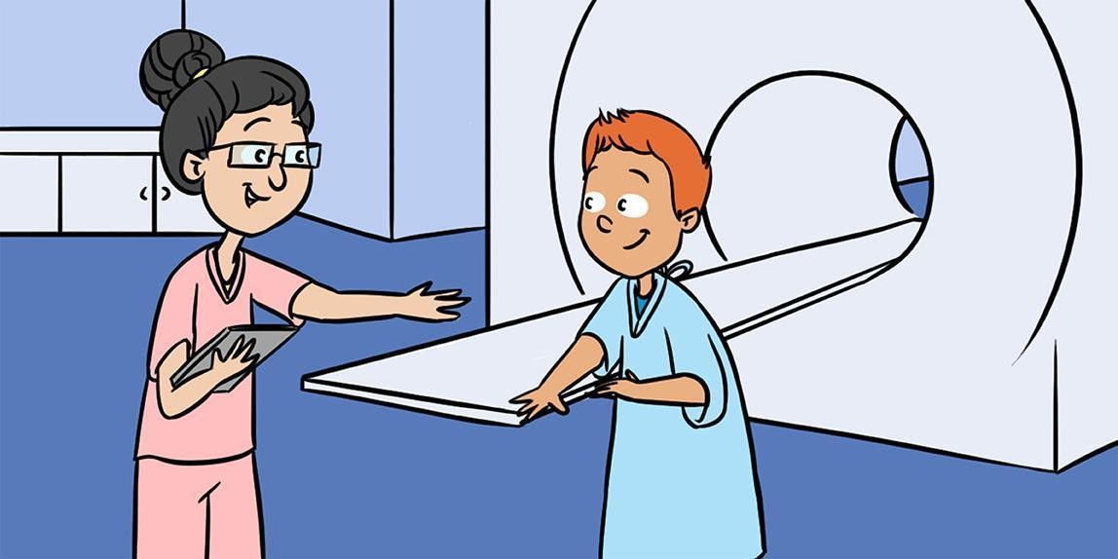
We’ll ask you to play a game for us whilst lying very still. The game will involve you choosing between shapes in order to win prizes. You can win these prizes for yourself and for others.
While you play this game, we’ll use our machine
to take a picture of your brain.

Email: dcp-lab@ucl.ac.uk Developmental Change and Plasticity Lab Telephone: 0207 - 6791156 26 Bedford Way 4th Floor
Room 430 London WC1H 0AP, UK

What will you do when we are finished?
The picture of your brain, how you did on the games and your answers to any questions we ask you will be kept safe and secure
with us. The only time we would tell someone about it is if we were worried about your safety.
At the end of the study, we will tell you what we discovered about our research on all the children that took part in our study. This will take a little bit of time, because there
are a lot of people coming to our study.

Email: dcp-lab@ucl.ac.uk Developmental Change and Plasticity Lab Telephone: 0207 - 6791156 26 Bedford Way 4th Floor
Room 430 London WC1H 0AP, UK

Do I have to take part?

If you don’t want to do this – just say no thank you!

If you have any questions, you can ask your mummy or daddy or the person who looks after you.

Thank you for reading!

Email: dcp-lab@ucl.ac.uk Developmental Change and Plasticity Lab Telephone: 0207 - 6791156 26 Bedford Way 4th Floor
Room 430 London WC1H 0AP, UK

To be filled in by your parent/guardian:

I confirm I have read and discussed this information with my child.

I confirm my child has agreed to take part in the study.

Your child’s name:………………………………
Your signature:……………………………………
Date:………………………………………………………

Email: dcp-lab@ucl.ac.uk Developmental Change and Plasticity Lab Telephone: 0207 - 6791156 26 Bedford Way 4th Floor
Room 430 London WC1H 0AP, UK

Video Consent Form
This study has been approved by the UCL Research Ethics Committee [Project ID Number]:12271/004

Title of Study: A behavioural and neurocomputational study of prosocial development.
Department: Clinical, Educational and Health Psychology
Name and Contact Details of the Researcher(s): Rolando Bonandrini & Francis Beveridge; email: dcp-lab@ucl.ac.uk
Name and Contact Details of the Principal Researcher: Nikolaus Steinbeis, 26 Bedford Way, London WC1H OAP, Tel: 0207-679-5396; email: n.steinbeis@ucl.ac.uk Name and Contact Details of the UCL Data Protection Officer: Alexandra Potts data- protection@ucl.ac.uk

Please fill out either Section A or Section B

Section A:

I agree to allow Dr. Nikolaus Steinbeis of the Developmental Change and Plasticity Lab and the Psychology Department of University College London to use the video recording of my child for one or more of the following purposes. I understand that my child’s face will be recognizable in the video. I understand that neither my name nor my child’s name will be associated with the image. I understand that I will be able to withdraw my child’s data up to a week after each testing point.

- Research and statistical analysis Signature:

- Publication in a scientific journal Signature:

- Demonstration at a scientific conference Signature:

- Demonstration to students Signature:

Date:

Section B:

I prefer not to have the video recording of my child used for research and statistical purposes, shown in publications, scientific conferences, or to students.

Signature:

Date:

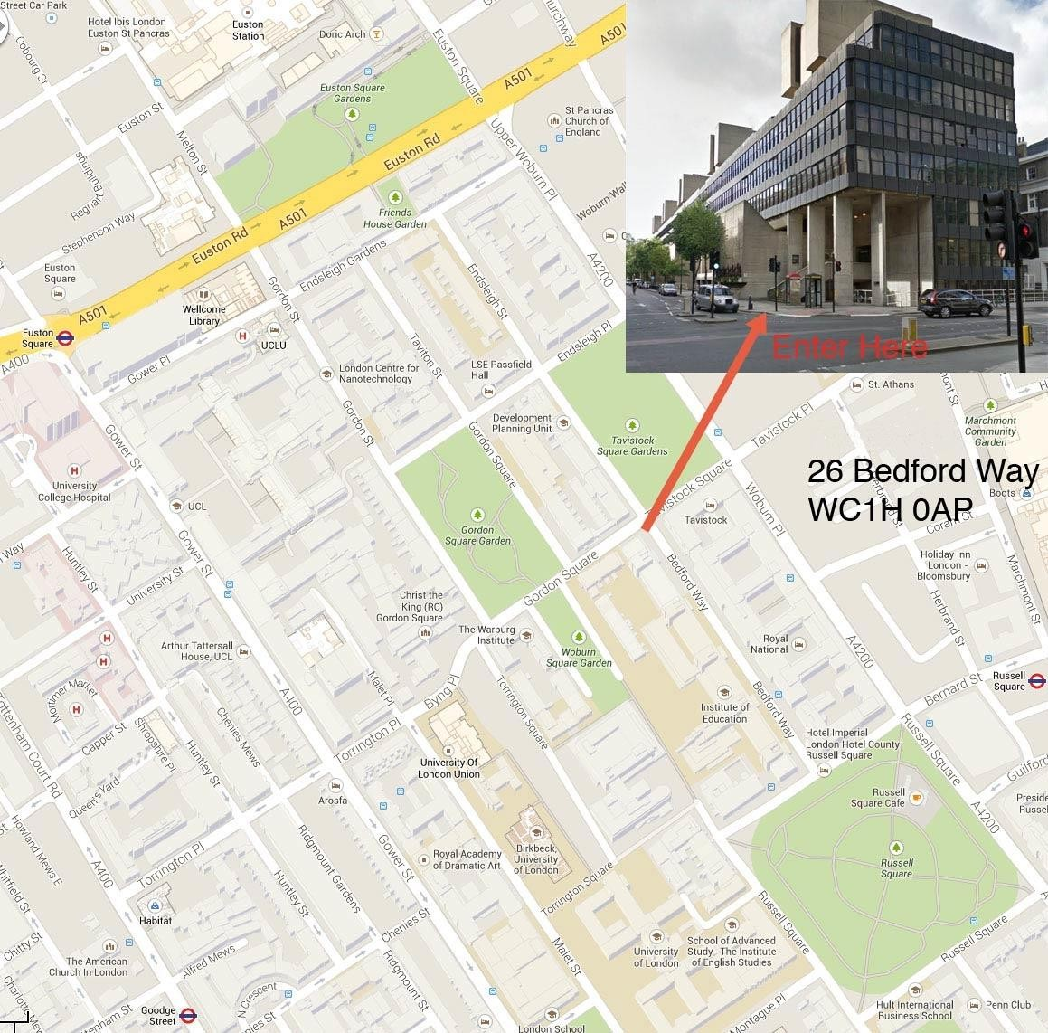
UCL DEPARTMENT OF PSYCHOLOGY

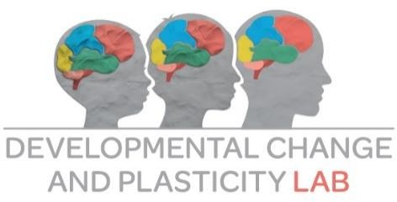
Where to find us
University College London - Department of Psychology - 26 Bedford Way, London, WC1H 0AP

How to reach us using public transport

London Underground (Tube):

The closest tube stations to UCL’s Bedford Way site are Russell Square (Piccadilly line), Euston Square (Hammersmith and City, Metropolitan and Circle lines) and Euston (Northern and Victoria lines). These are about a 5 minute walk away. Holborn (Central and Piccadilly lines) is also only a short walk away.

More information and a journey planner can be found at www.tfl.gov.uk/tube

Bus:

Bedford Way is served by many Transport for London bus routes. Buses 59, 68, 91, 168 and 188 all have stops near Russell Square station, about five minutes’ walk from UCL.

More information and a journey planner can be found at www.tfl.gov.uk/buses

National Rail:

There are many mainline rail stations just a short journey away from UCL. The stations at Euston, King’s Cross and St Pancras being within easy walking distance.

National Rail enquiries can be found at www.nationalrail.co.uk

How to reach us if coming by car

There is an RCP car park located at:
Bernard Street, London, WC1N 1LE (next to the Holiday Inn)

